Outdoor Lighting Standards
Sections:
Purpose
Conformance with applicable codes
Conflict Regulations
Applicability
General Outdoor Lighting Standards
Outdoor Lighting standards by type
Prohibited lighting
Special Uses
Exemptions and nonconforming lights
Plan submittal and evidence of compliance
Approved materials and methods of construction or installation/operation
Violations, legal actions and penalties
Tables and information sheets
Definitions

Purpose
It is the purpose and intent of this chapter to balance the goals of providing efficient and practical lighting for residents and business in (Municipality), maintaining the city’s rural character, minimizing light pollution that may interfere with the enjoyment, health, safety, and welfare of (Municipality’s) citizens and visitors or with the adjacent military activity, and reducing energy consumption.
Conformance with applicable Codes
All outdoor lighting and lighting fixtures shall be installed in conformance with the provisions of this chapter and the applicable building codes currently in effect in the city
Conflict Regulations
Where any provision of federal, state, county, or city statutes, codes, or laws conflicts with any provision of this chapter, the most restrictive shall govern unless enforcement will result in a violation of the federal, state, county or city statutes, codes, or laws.
Applicability
A. New Lighting. All outdoor lighting installed after the effective date of the ordinance codified in this chapter shall conform to the standards established in this chapter.
B. Existing Lighting. All lighting installed prior to the effective date of the ordinance codified in this chapter shall not be subject to the requirements of this chapter, except that any existing lighting that is directly impacted as part of a project that requires an application for an Municipality site plan or building permit is required to be brought into conformance with this chapter. All lighting shall be upgraded to conform to this chapter prior to the issuance of certificate of occupancy or final inspection.
C. Public Roadways. This chapter does not apply to lights owned or maintained by the city, state or federal government which are within any road rights-of-way or used for traffic or safety purposes

General Outdoor Lighting Standards
A. Lamp and Shielding. All permanent light fixtures are required to be full cutoff fixtures with the light source fully shielded for all uses and directed downward, including single-family and multifamily residential uses.
B. Light sources shall be at least as efficient as LED and no greater than four thousand (4,000) K in correlated color temperature (CCT)
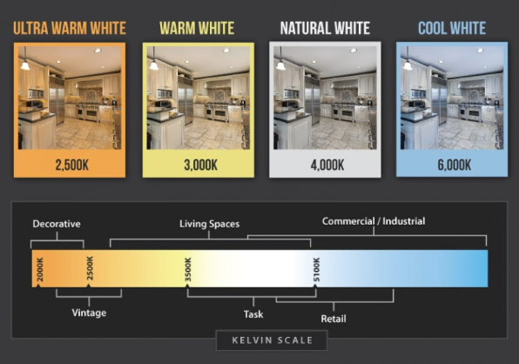
C. Light Trespass Standard. All light fixtures, including security lighting, shall be aimed and shielded so that the direct illumination shall be confined to the property boundaries of the source. Particular care is to be taken to assure that the direct illumination does not fall onto or across any public or private street or road. Motion sensing light fixtures shall be fully shielded and properly adjusted, according to the manufacturer’s instructions, to turn off when detected motion ceases.
D. Total Outdoor Light Output Standards – Nonresidential and Multifamily Uses. Total outdoor light output shall not exceed 100,000 lumens per net acre for all development except single-family residential uses. This cap is not intended to be achieved in all cases or as a design goal. Instead, design goals should be the lowest levels of lumens necessary to meet the lighting requirements of the site.
E. Total Outdoor Light Output Standards – Single-Family Residential Uses. Outdoor lighting for single-family residential uses is not subject to a lumens per net acre cap, but is subject to the lamp fixture and shielding requirements.
F. Height. Any lighting fixture attached to a structure shall be placed below the eave or parapet, whichever is lower. Different height restrictions may be imposed as a condition of approval by the planning director, development review committee, or planning commission.
G. Commercial Lighting Time Limitations. All nonessential commercial exterior lighting shall only continue in operation until 11:00 p.m. or for as long as the business is open or area is in active use and shall remain off until the business reopens or until daylight the following day

Outdoor Lighting standards by type
A. Parking Lot Standards. Parking lot lighting poles shall be sized in such a manner that the top of any fixture does not exceed 17 feet above adjacent grade. Parking area lights are encouraged to be greater in number, lower in height and lower in light level, as opposed to fewer in number, higher in height and higher in light level. Low pressure sodium (LPS) lamps are encouraged. Alternatively, in industrial areas, parking lot lighting poles may be allowed to a height of 30 feet above adjacent grade provided full-cut-off light fixtures with built-in motion sensors for each pole are used. Motion sensors must reduce the light level to 50 percent when no motion is detected for 30 minutes.
B. Luminaire Mounting Height. Freestanding luminaires within a residential zone, except street lights, shall be mounted at a height no greater than 12 feet from ground level to the top of the luminaries.
C. Landscape and Accent Lighting. Subject to the approval of the planning director or designee, ground-mounted lighting may be allowed to accent unique features of a building and/or surrounding landscaping (such as outstanding architectural features, specimen trees with dense year-round foliage or large native shrub masses). Architectural lighting is allowed; provided, that a full cutoff light fixture is used, and the source of illumination is directed downward.
D. Flagpoles. Uplighting for flags is permitted, provided the flag is of a government and the maximum lumen output is 1,300 lumens.

Prohibited lighting
A. Searchlights, laser source lights, strobe or flashing lights, illusion lights or any similar high intensity light shall not be permitted except in emergencies by police and fire personnel or for approved special events.
B. Uplighting. Except as specifically allowed in this chapter is prohibited

Special Uses
A. Outdoor Recreational Facilities. Lighting for outdoor recreation facilities that does not comply with this chapter may be approved with the project site plan based on the following:
1. When the proposed lumens per acre exceed the lumens per net acre limits, the installation shall be designed to achieve no greater than the minimum illuminance levels for the activity as recommended by the Illuminating Engineering Society of North America (IESNA).
2. Every such lighting system design shall be certified by a Utah registered engineer as conforming to all applicable restrictions of this code.
3. Such lighting shall not include any light trespass as determined by the planning director or designee.
4. Fully cutoff light fixtures shall be required for fields designed for amateur, recreational or nonprofessional sports activity. For professional level sports facilities where full cutoff fixtures are not utilized, acceptable luminaries shall include those which:
a. Are provided with internal or external glare control louvers, or both, and installed so as to minimize uplight and off-site light trespass as determined by the planning director; and
b. Are installed and maintained with aiming angles that permit no greater than two percent of the light emitted by each fixture to project above the horizontal.
B. Outdoor Display Lots.
1. All such lighting shall utilize full cutoff fixtures.
2. When the proposed lumens exceed the per acre limits, the installation shall be designed to achieve no greater than the minimum illuminance levels for the activity as recommended by the Illuminating Engineering Society of North America (IESNA).
3. Such lighting shall not include any light trespass as determined by the planning director or designee.
4. Every such lighting system design shall be certified by a Utah registered engineer as conforming to all applicable restrictions of this code.
C. Service Station Canopies. All service station canopies shall comply with the following:
1. Shielding. All luminaries shall be flush with the lower surface of canopies and utilize flat glass or plastic covers.
2. Total Under-Canopy Output. The total light output used for illuminating service station canopies, defined as the sum of under-canopy initial bare-lamp outputs in lumens, shall not exceed 40 lumens per square foot of canopy. All lighting mounted under the canopy, except internally illuminated signs, shall be included in the total. Fifty percent of the total lumen output of all lamps mounted within or under a canopy shall be included in the lumen per acre cap.
D. Other Special Use Lighting. Lighting for special uses that are not specified in this chapter must be approved by planning commission through a conditional use permit or along with a site plan application.

Exemptions and nonconforming lights
A. Emergency lighting, used by police, firefighting, or medical personnel, or at their direction, is exempt from all requirements of this code for as long as the emergency exists.
B. Spotlights are permitted for single-family residential, provided they are fully shielded and directed downward.
C. Swimming Pool and Decorative Water Fountain Lighting. Underwater lighting used for the illumination of swimming pools and decorative water fountains is exempt from the lamp type and shielding standards, though they must conform to all other provisions of this code.
D. Seasonal Decorations. Seasonal decorations are exempt from this chapter.

Plan submittal and evidence of compliance
A. Plan Submittal. Whenever a person is required to obtain a permit for outdoor lighting or signage, a conditional use permit, subdivision approval or any development plan approved by the city, including all city projects, or a building permit, the applicant shall, as part of the application process, submit sufficient information to enable the planning director or designee to determine whether proposed lighting complies with this code. All applications may be subject to review and action by the planning commission at the discretion of the planning director.
B. Applications. All applications shall include the following:
1. A site plan indicating the location of all lighting fixtures, both proposed and any already existing on the site.
2. A description of each illuminating device, fixture, lamp, support and shield, both proposed and existing. The description shall include, but is not limited to, manufacturer’s catalog cuts and illustrations (including sections where required); lamp types, wattages and initial lumen outputs.
3. Such other information that the planning director may determine is necessary to ensure compliance with this code.
C. Plan Approval. If the planning director or designee determines that any proposed lighting does not comply with this code, the permit shall not be issued or the plan approved.
D. Lamp or Fixture Substitution. Should any outdoor light fixture or the type of light source therein be changed after the permit has been issued, a change request must be submitted to the planning director or designee for approval, together with adequate information to assure compliance with this code, which must be received prior to substitution.
E. Certification of Installation. For all projects where the total initial output of the proposed lighting equals or exceeds 100,000 lamp lumens, certification that the lighting, as installed, conforms to the approved plans shall be provided by a certified engineer before the certificate of occupancy is issued. Until this certification is submitted, approval for use of a certificate of occupancy shall not be issued for the project

Approved materials and methods of construction or installation/operation
A. Approval of Alternatives. The provisions of this code are not intended to prevent the use of any design, material, or method of installation or operation not specifically prescribed by this code, provided any such alternate has been approved by the planning director or designee. The planning director may approve any such proposed alternate if it:
1. Provides at least approximate equivalence to that applicable specific requirement of this code, and
2. Complies with the intent of this code.

Violations, legal actions and penalties
A. Violations and Legal Actions. If, after investigation, the planning director finds that any provision of this chapter is being violated, the planning director or designee shall give notice by hand delivery or by certified mail, return receipt requested, of such violation to the owner and/or occupant of such premises, demanding that the violation be abated within 30 days of the date of hand delivery or of the date of mailing of the notice. The planning department staff shall be available to assist in working with the violator to correct said violation. If the violation is not abated within the 30-day period, the planning director or designee may institute actions and proceedings, either legal or equitable, to enjoin, restrain or abate any violations of this chapter and to collect penalties for such violations.
B. Penalties. A violation of this chapter, or any provision thereof, shall be punishable by a civil penalty of $75.00 per day and each day of violation after the expiration of the 30-day period shall constitute a separate offense for the purpose of calculating the civil penalty.

Tables and information sheets
The figures and information sheets attached to the ordinance codified in this chapter shall be incorporated into this chapter as guidelines for the public and the city. The city does not endorse or discriminate against any manufacturer or company that may be shown, portrayed or mentioned by the examples
Definitions
A. “Direct illumination” means illumination resulting from light emitted directly from a lamp, luminary, or reflector and is not light diffused through translucent signs or reflected from other surfaces such as the ground or building faces.
B. “Display lot or area” means outdoor areas where active nighttime sales activity occurs and where accurate color perception of merchandise by customers is required. To qualify as a display lot, one of the following specific uses must occur: automobile sales, boat sales, tractor sales, building supply sales, gardening or nursery sales, and assembly lots. Uses not on this list may be approved as display lot uses by the planning director or designee.
C. “Foot-candle” means one lumen per square foot; unit of illuminance. It is the luminous flux per unit area in the imperial system. One foot-candle equals approximately one-tenth (0.093) lux.
D. “Fully shielded light fixture” means a light fixture that is shielded in such a manner that light rays emitted by the fixture, either directly from the lamp or indirectly from the fixture, are projected below a horizontal plane running through the lowest point on the fixture where light is emitted. The term “full cutoff” is often substituted for the term “fully shielded.” The terms are not equivalent. Fully shielded luminaires emit no direct uplight, but have no limitation on the intensity in the region between 80 degrees and 90 degrees.
E. “Full cutoff light fixture” means fixtures that are independently certified by the manufacturers, and do not allow light to be emitted above the fixture and the fixture reduces glare by limiting the light output to less than 10 percent at and below 10 degrees below the horizontal.
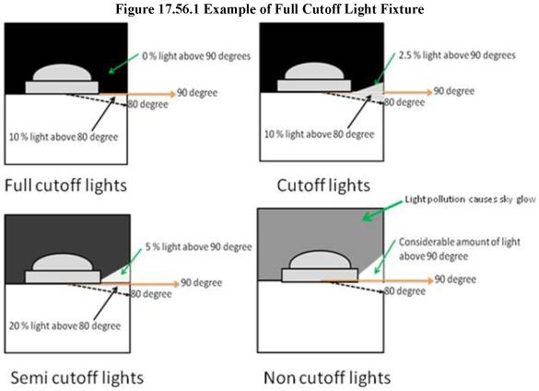
F. “Glare” means the sensation produced by a bright source within the visual field that is sufficiently brighter than the level to which the eyes are adapted to cause annoyance, discomfort, or loss in visual performance and visibility; blinding light. The magnitude of glare depends on such factors as the size, position, and brightness of the source, and on the brightness level to which the eyes are adapted.
G. “Installed” means a light fixture attached or fixed in place, whether or not connected to a power source, of any outdoor light fixture.
H. “Light pollution” means any adverse effect of manmade light.
I. “Light trespass” means light spill falling over property lines that illuminates adjacent grounds or buildings in an objectionable manner.
J. “Lumen” means a unit used to measure the actual amount of visible light which is produced by a lamp as specified by the manufacturer.
K. “Luminary” means the complete lighting assembly, less the support assembly.
L. “Motion sensing security lighting” means any fixture designed, and properly adjusted, to illuminate an area around a residence or other building by means of switching on a lamp when motion is detected inside the area or perimeter, and switching the lamp off when the detected motion ceases.
M. “Net acreage” means the remaining ground area of a parcel after deleting all portions for proposed and existing public rights-of-way and undeveloped area.
N. “Nit” means the standard unit of brightness for electronic and digital signage. It is a measure of the light being emitted by the sign, in contrast to foot-candles which measure the brightness of the surface area or object that is being lighted.
O. “Nonessential commercial exterior lighting” means any signs, parking lot lighting, display lighting, exterior building lighting, directional lighting or landscape lighting that is primarily for aesthetic or advertising purposes and does not directly contribute to the safety or security of the premises.
P. “Outdoor light fixture” means an outdoor illuminating device, outdoor lighting or reflective surface, lamp or similar device, permanently installed or portable, used for illumination, decoration, or advertisement. Such devices shall include, but are not limited to, lights used for:
1. Buildings and structures;
2. Recreational areas;
3. Parking lot lighting;
4. Landscape lighting;
5. Architectural lighting;
6. Signs (advertising or other);
7. Street lighting;
8. Product display area lighting;
9. Building overhangs and open canopies;
10. Security lighting.
Q. “Outdoor recreation facility” means an area designed for active recreation, whether publicly or privately owned, including, but not limited to, parks, baseball diamonds, soccer and football fields, golf courses, tennis courts, and swimming pools.
R. “Partially shielded light fixture” means a fixture shielded in such a manner that no more than 10 percent of the light emitted directly from the lamp or indirectly from the fixture is projected at an angle above the horizontal, as determined by photometric test or certified by the manufacturer. Luminaries mounted under canopies or other structures such that the surrounding structure effectively shields the light in the same manner are also considered partially shielded for the purposes of this code.
S. “Seasonal decorations” means strings of holiday lights, uplighting or internally lit inflatable or plastic decorations, or other lighting of holiday or seasonal decorations.
T. “Uplighting” means lighting that is directed in such a manner as to shine light rays above the horizontal plane.
U. “Security lighting” means lighting designed to illuminate a property or grounds for the purpose of visual security.
V. “Unshielded fixture” means any fixture that allows light to be emitted above the horizontal directly from the lamp or indirectly from the fixture or a reflector.
W. “Watt” means the unit used to measure the electrical power consumption (not the light output) of a lamp. [Ord. O-12-2014 (Exh. A)].
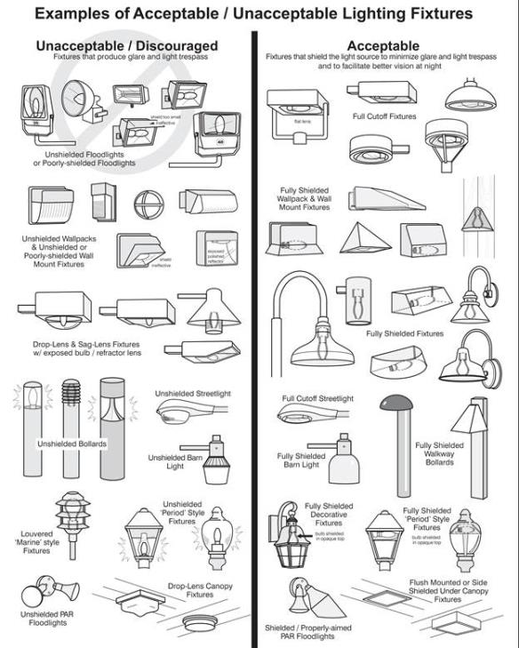
[Ord. O-12-2014 (Exh. A)].

